Viewing my
GP Patient Record Online Guide

Empowering and Educating Patients

Supported By
Greater Huddersfield Clinical Commissioning Group

An Introduction to Viewing My GP Patient Record Online
Please use the information in this guide to help you decide if you want access to your GP Patient Record.
What is a GP Patient Record?
A health record (sometimes referred to as medical record) should contain all the clinical information about the care you received. This is important so every health professional involved at different stages of your care has access to your medical history such as allergies, operations or tests. Based on this information, the health professional can make judgements about your care going forward.
You can now see your GP Patient Record via the internet if you have the right equipment (for example a home computer, smartphone or laptop). To be able to see it, you will need to log on to a website using a password or download the app. We also need your permission to create access to the system where your record is kept.
Why you might want to see your GP Patient Record
- I can have the information I need to make an informed choice
- I can have a say in making decisions about my treatment and care along with a healthcare professional
- I can check the accuracy of my GP Patient Record and ask the GP surgery to amend if necessary
- I feel empowered to become more involved in my healthcare
- I can access it if needed on holiday or abroad
- I can view test results without having to contact my GP surgery
- I am confident that my GP surgery is open, honest and trustworthy
- I have the convenience of accessing my record seven days a week, 24 hours a day
Is my confidential medical information safe whilst I am looking at it online?
- The details you can see online come from a national clinical IT system that your GP surgery uses. This IT system encrypts (scrambles) information to make it very difficult for anyone else to receive or see it.
- Your medical information is not kept on a computer in your surgery. It is held in the secure national IT system and your password access calls the information from that server to your computer so you can see it. This is also how staff at your GP surgery view or add information to your record.
What will I see in my GP Patient Record?
- A summary of your health record includes the date of any consultations you’ve had with a GP, practice nurse or other health practitioner.
- A note of anything you’re allergic to
- Test results
- Vaccinations
- Medicine you’ve been prescribed
Consenting to viewing my GP Patient Record
- Make sure that you have read the information in this guide.
- You must sign a consent form before you can start viewing your GP Patient Record.
- Hand your signed Registration and Consent form to the GP surgery receptionist.
If you are completing the form for someone else because they cannot do it themselves, please sign the patient representative Registration and Consent form.
A member of the surgery team will get in touch to confirm your online access to your records

If you find a mistake when viewing your GP patient Record please contact your GP surgery straight away.

The surgery has the right to remove online access to services for anyone that does not use them responsibly.

What identification do you need to sign up for your GP Patient Record?
Two forms of documentation must be provided as evidence of identity and one of these must contain a photo. Acceptable documents include:
- Passports
- Photo driving licences (full or provisional)
- Birth or adoption certificate
- UK asylum seekers Application Registration Card
- Current household bill (gas, electric, house insurance)
- Current residence permit (issued by the Home Office to EU nationals)
- Current council tax bill
- Bank statements
- Unsecured personal loan account (excluding pay day loans)
- National 60+ bus pass
- Marriage certificate
- Student loan account

If you are unsure about any form of identification, please contact the GP surgery and we will confirm if it is acceptable.

Keeping your online health and social care records safe and secure
There can be great benefits from having access to your health and social care records online. But your records contain personal and sometimes sensitive information, so it’s important to keep them safe.
It will be your responsibility to keep your login details and password safe and secure. If you know or suspect that your record has been accessed by someone that you have not agreed should see it, then you should change your password immediately.

If you can’t do this for some reason, we recommend that you contact the surgery so that they can remove online access until you are able to reset your password.

If you print out any information from your record, it is also your responsibility to keep this secure. If you are at all worried about keeping printed copies safe, we recommend that you do not make copies at all.

Create a strong password and keep it safe
- Your password and other information for logging on are important for keeping your records safe and secure. Set up a strong password and keep it secret.
- If you think someone might have seen your records without your permission, change your password straightaway and contact your record provider.
Get into good habits online
- Protect the computer or mobile device you use to access your records – for example, by using a password or PIN and anti -virus software.
- It’s best to view your records in private on your own computer or mobile device. Be particularly careful about the security of your records if you’re accessing them while on the move.
Share your records safely, or not at all
- Before you share your records with anyone else, consider whether it’s in your best interests and what they might do with the information, now or in the future. If you’re in any doubt, don’t share.
- If someone is trying to force you to share your records, tell your health or social care professional.
A strong password is:
- A secret
- Easy for you to remember, or is kept somewhere safe
- At least eight characters long
- Changed regularly
- Only used for your health or social care records

Further information available at: http://www.nhs.uk/NHSEngland/thenhs/records/healthrecords/Pages/overview.aspx

Glossary of Terms

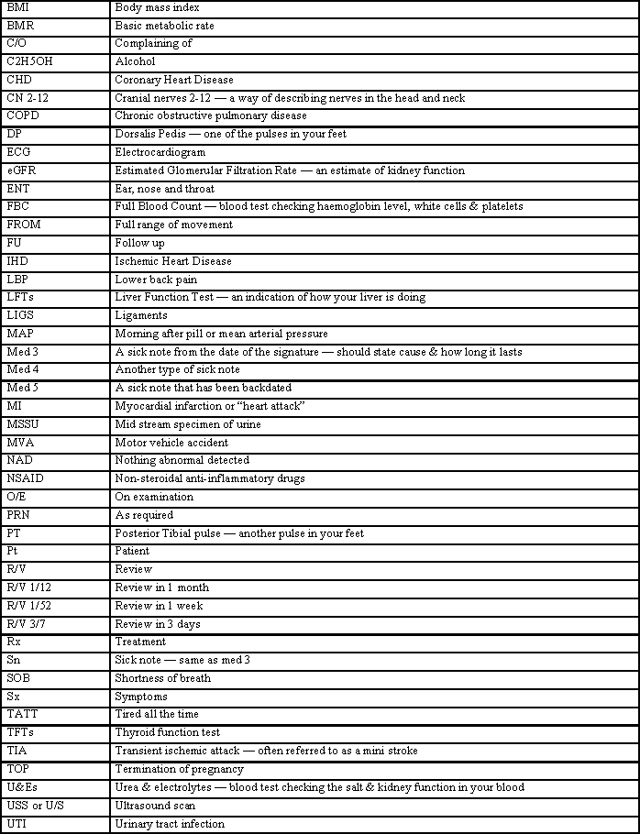

If you come across any abbreviations that you do not understand, please get in touch with your surgery and one of the team will find the answer for you.

Or you could try this website which may be helpful. http://www.pharma-lexicon.com
University Health Centre Drs Mounsey & Rasakumaran

Electronic Health Record Access
What is coercion?
“Coercion” is the act of governing the actions of another by force or by threat, in order to overwhelm and compel that individual to act against their will.
Online services of all types are vulnerable to coercion. In the context of Patient Online, coercion might result in patients being forced into sharing information from their record, including login details, medical history, repeat prescription orders, GP appointment booking details and other private, personal information.
Would someone else ask for your access to your medical information if you were given on-line access?
Yes No
At present we are automatically giving patients access to their full medical records from their registration date. Please sign below if you consent to being opted-in to this service.

Print Name _________________________________________________________

Signed ________________________________________ Date________________

However, we are able to offer full access to your previous medical records, if you are interested in this service please complete the below Registration and consent forms.

Registration and Consent form

First name: | Surname:
Address:

Postcode: |  | Date of birth:
Email address:
Telephone number: | Mobile number:

I wish to have access to the following online services (please tick all that apply):
1. Booking appointments | □
2. Requesting repeat prescriptions | □
3. Accessing my medical record | □

I wish to access my GP Patient record online and understand and agree with each statement (tick)
1. I have read and understood the information provided by the surgery | □
2. I will be responsible for the security of the information that I see or download | □
3. If I choose to share my information with anyone else, this is at my own risk | □
4. I will contact the surgery as soon as possible if I suspect that my account has been accessed by someone without my agreement | □
5. If I see information in my record that is not about me or is inaccurate, I will contact the surgery as soon as possible | □

Signature: | Date:

For surgery use only
Patient NHS number: |  |  | Surgery computer ID number:
Identity verified by: (initials) | Date: |  | Vouching □  Vouching with information in record □  Photo ID and proof of residence □
Authorised by: |  |  |  | Date:
Date account created: Date passphrase sent:
Level of record access enabled  Tick one box only  □ Summary  □ DCRA  □ Full |  | Notes / explanation

Patient’s Representative
Registration and Consent form
Patient details
First name: | Surname:
Address:

Postcode: |  | Date of birth:
Email address:
Telephone number: | Mobile number:

Representative details
First name: | Surname:
Address:

Postcode: |  | Date of birth:
Email address:
Telephone number: | Mobile number:

I wish to have access to the following online services (please tick all that apply):
1. Booking appointments | □
2. Requesting repeat prescriptions | □
3. Accessing my medical record | □

I wish to access the GP Patient record online and understand and agree with each statement (tick)
1. I have read and understood the information provided by the surgery | □
2. I will be responsible for the security of the information that I see or download | □
3. If I choose to share my information with anyone else, this is at my own risk | □
4. I will contact the surgery as soon as possible if I suspect that my account has been accessed by someone without my agreement | □
5. If I see information in my record that is not about me or is inaccurate, I will contact the surgery as soon as possible | □

Patient signature: | Date:
Representatives signature: | Date:

For surgery use only
Patient NHS number: |  |  | Surgery computer ID number:
Identity verified by: (initials) | Date: |  | Vouching □  Vouching with information in record □  Photo ID and proof of residence □
Authorised by: |  |  |  | Date:
Date account created: Date passphrase sent:
Level of record access enabled  Tick one box only  □ Summary  □ DCRA  □ Full |  | Notes / explanation

